**Lab 5**

1. **Check Docker**

* docker - -version
* docker info
  + 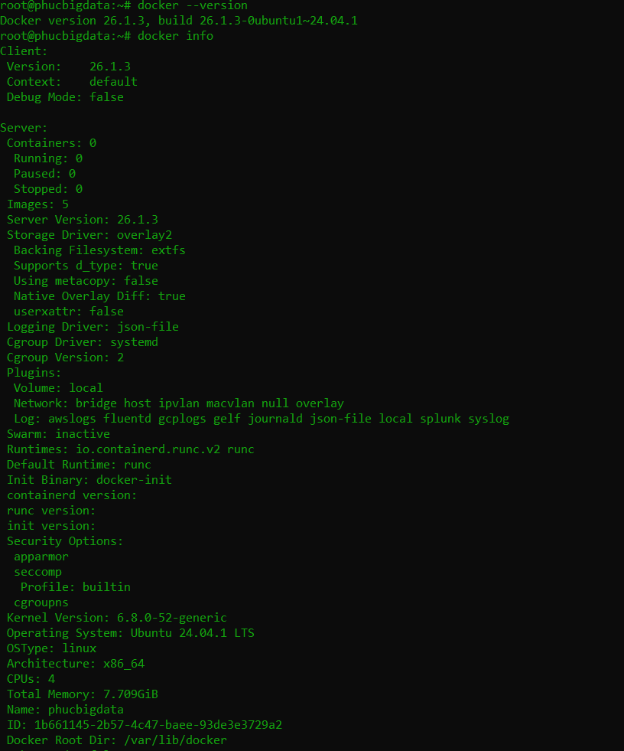
* systemctl status docker
  + 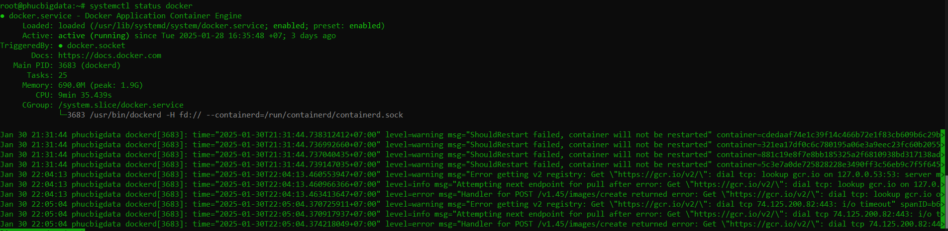

1. Set up Kubernetes (kubectl, kubeadm, kubelet)

* sudo apt update
* sudo apt install -y apt-transport-https ca-certificates curl
* curl -fsSL https://pkgs.k8s.io/core:/stable:/v1.30/deb/Release.key | sudo tee /etc/apt/trusted.gpg.d/kubernetes.asc
* echo "deb https://pkgs.k8s.io/core:/stable:/v1.30/deb/ /" | sudo tee /etc/apt/sources.list.d/kubernetes.list
* sudo apt update
  + 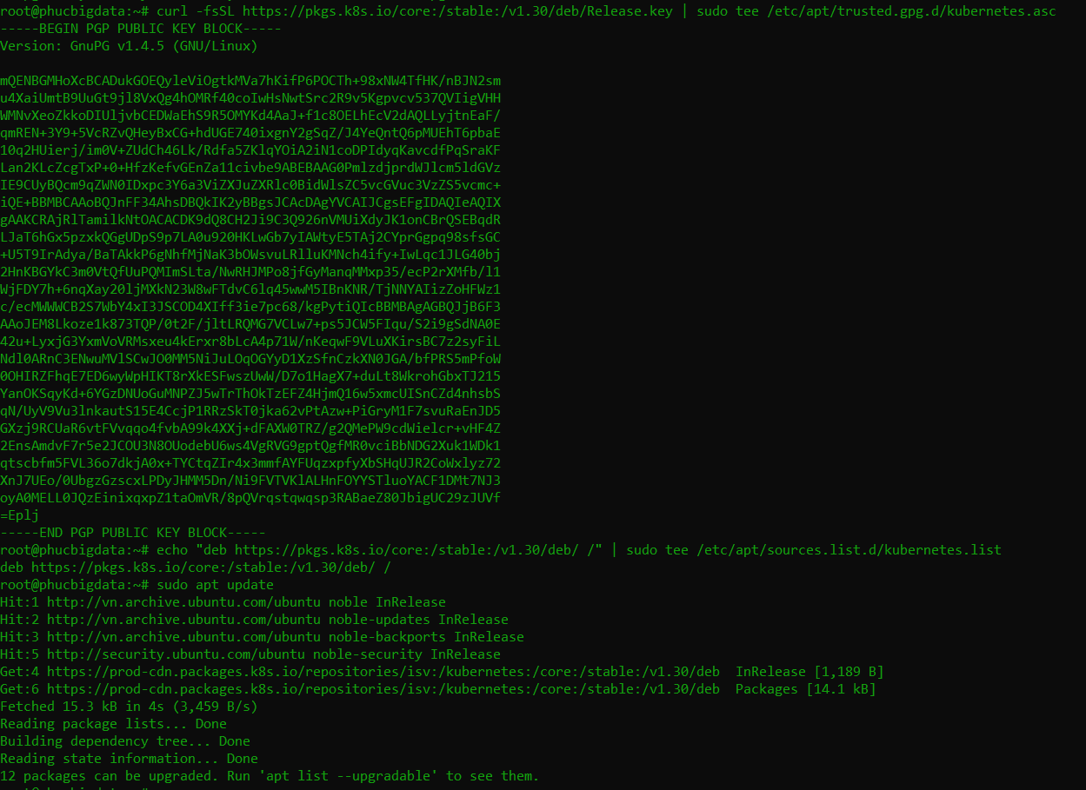
    - PUBLIC KEY BLOCK
      * 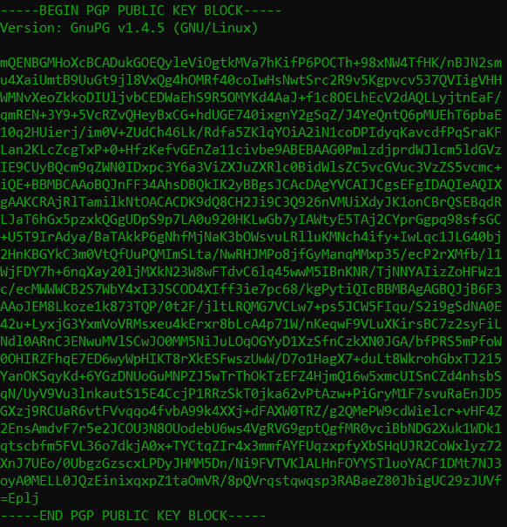
* sudo apt install -y kubelet kubeadm kubectl
* sudo apt-mark hold kubelet kubeadm kubectl
  + 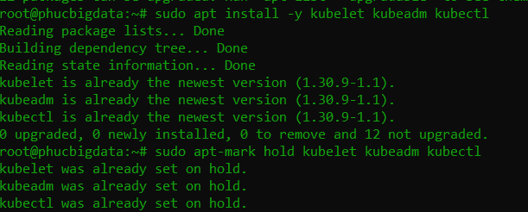
* kubectl version –client
* kubeadm version
  + 

1. Configuration Kubernetes

* sudo kubeadm init --pod-network-cidr=10.244.0.0/16 --apiserver-advertise-address=192.168.255.4
* kubectl version --client
* kubectl config view
* kubectl get nodes
  + 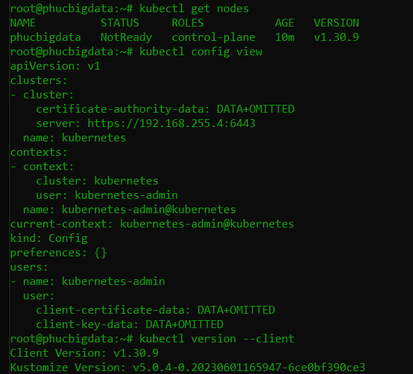

1. **Install CNI NETWORK**

* kubectl apply -f <https://docs.projectcalico.org/manifests/calico.yaml>
* kubectl get pods --all-namespaces
  + 

1. **Deploying Apache Spark on Kubernetes**
   1. **Clone Repository Spark Configuration**
   * git clone https://github.com/ibm-developer-skills-network/fgskh-new_horizons.git
   * cd fgskh-new_horizons
   1. **Create Alias ​​For kubectl**
   * alias k='kubectl'
   * kubectl get nodes
     + 
2. **Start Apache Spark Pod**

* k apply -f spark/pod_spark.yaml
* k get po
  + 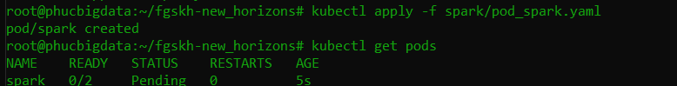
  + 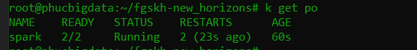

1. **Test connection to Apache Spark Pod**

* k exec spark -c spark -- echo "Hello from inside the container"
* kubectl exec -it spark -c spark -- ./bin/spark-submit \
* > --master k8s://http://127.0.0.1:8001 \
* ode clus> --deploy-mode cluster \
* > --name spark-pi \
* > --class org.apache.spark.examples.SparkPi \
* ces=1 \
* > --conf spark.executor.instances=1 \
* > --conf spark.kubernetes.container.image=romeokienzler/spark-py:3.1.2 \
* > --conf spark.kubernetes.executor.request.cores=0.2 \
* > --conf spark.kubernetes.executor.limit.cores=0.3 \
* > --conf spark.kubernetes.driver.request.cores=0.2 \
* > --conf spark.kubernetes.driver.limit.cores=0.3 \
* > --conf spark.driver.memory=512m \
* > --conf spark.kubernetes.namespace=default \
* > local:///opt/spark/examples/jars/spark-examples_2.12-3.1.2.jar 10
  + 